CAN Documentation Notes

- On REV, the message IDs are different (ALL COMMANDS doc might be old version??)
- Here are the conversions:
  - 0x2051801 2051800 (API ID: 0x60 0x60)
  - 0x205b801 2051840 (API ID: 0x2e0 0x61) ---- this is where we can get current from
  - 0x205b841 2051880 (API ID: 0x2e0 0x62)
  - 0x205b8c1 20518C0 (API ID: 0x2e3 0x63)
  - 0x205b941
  - 0x205bc01

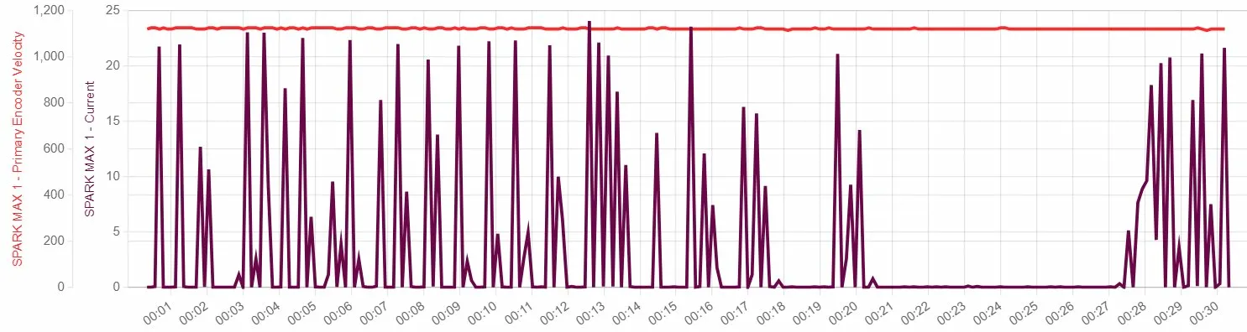

- The rpm is constant
- The current fluctuates, which shouldn’t be happening. Possible errors:
  - Something is intermittently contacting the rotor — causing brief load spikes that immediately resolve
  - Bearing damage or debris — causing the shaft to momentarily bind then release
  - The motor is driving a load that is periodically resisting (like a fan blade hitting something)
  - Loose wiring on one of the three motor phases — causing the controller to work harder to maintain speed on two phases intermittently
- Next Steps:
  - Run with computer power supply (ask Jaylan) It could a problem with the power supply

